**Apresentação Printscreens Trello Fase 2 - Grupo 52**

Fig1. - Trello Overview

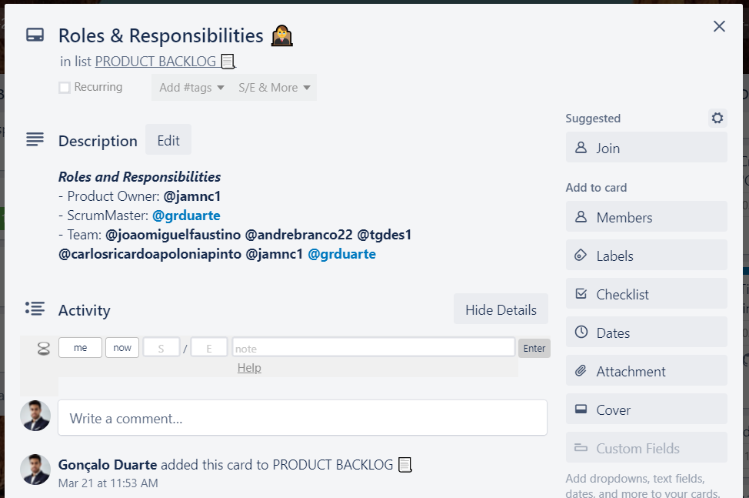

Fig2. - Product Backlog – Roles & Responsibilities

Fig3. - Product Backlog – O que era esperado para a Fase 2

Fig4. – Exemplo de tarefa do Sprint 2   
(uso de label, identificação de membros, data e descrição com link de atalho para o ficheiro na pasta partilhada da equipa de projecto.)

Fig4. – Exemplo de tarefa do Sprint 2   
(uso de label, identificação de membros, data e anexo da branch de GitHub)

Fig5. - Lista de tarefas concluídas

Fig6. - A nossa Sprint Review Meeting  
(uso de label, identificação de membros, data e checklist de tarefas concluídas)

Fig7. – Exemplo de reunião Daily Scrum  
(identificação de membros, data, objetivos da reunião)